# Formatting a Report

Download and install AdventureWorks (OLTP) full database backups

<https://github.com/Microsoft/sql-server-samples/releases/tag/adventureworks>

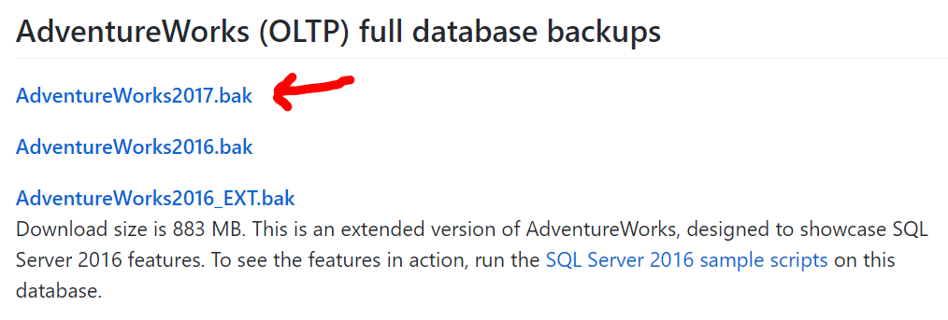

Run this query in SSMS <https://github.com/laploy/SSMS2017/blob/master/0110%20Formatting%20a%20Report.sql>

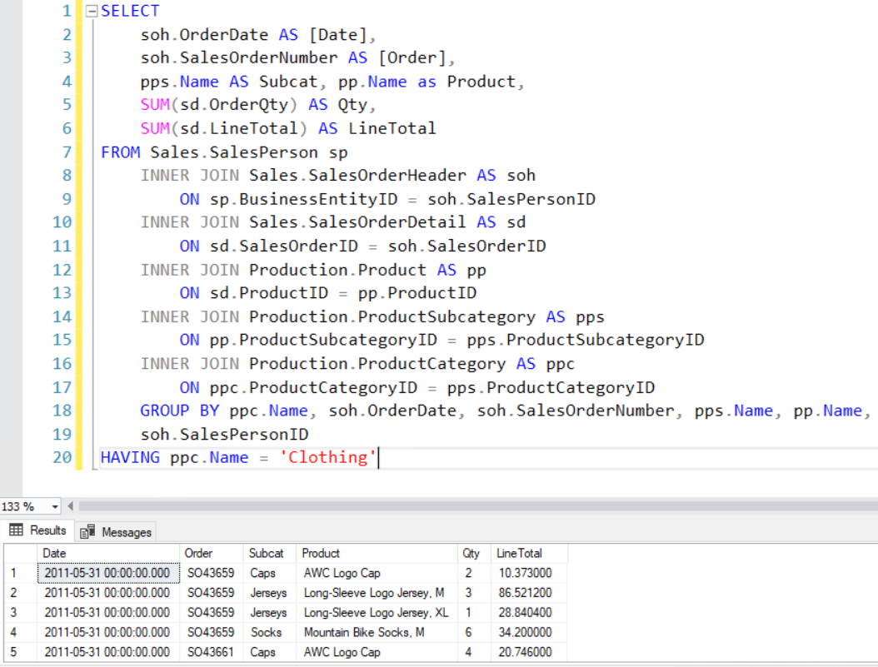

* Create a new Report Server Project 0100 Formatting Report
* Create a new Report Format.rdl
* Specifying Connection Information (Create a new data source)
* Defining a Dataset for the Table Report using the query

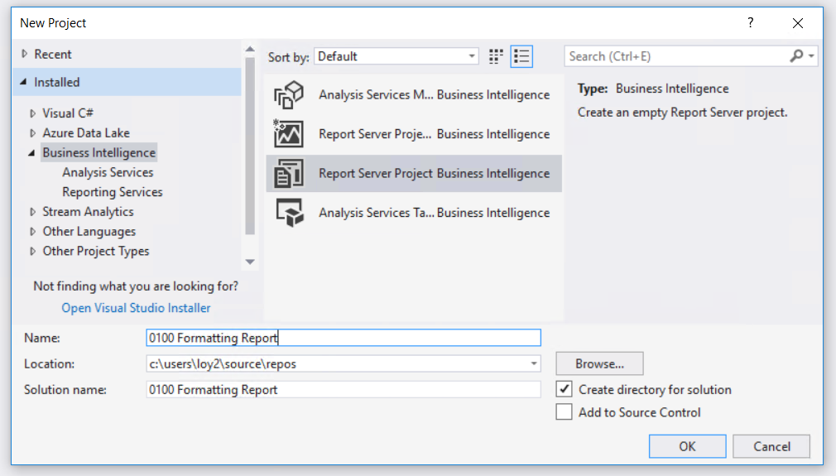

* Adding a Table to the Report

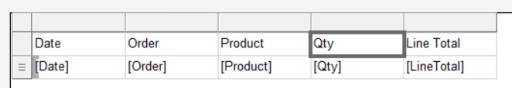

* Preview

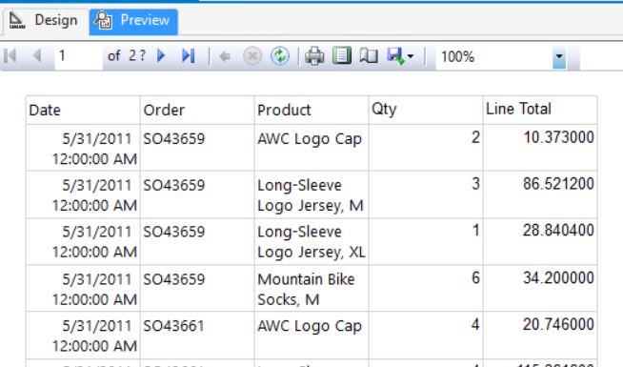

Format the Date

1. Click the Design tab.
2. Right-click the cell with the [Date] field expression and then click Text Box Properties.
3. Click Number, and then in the Category field, click Date.
4. In the Type box, select January 31, 2000.
5. 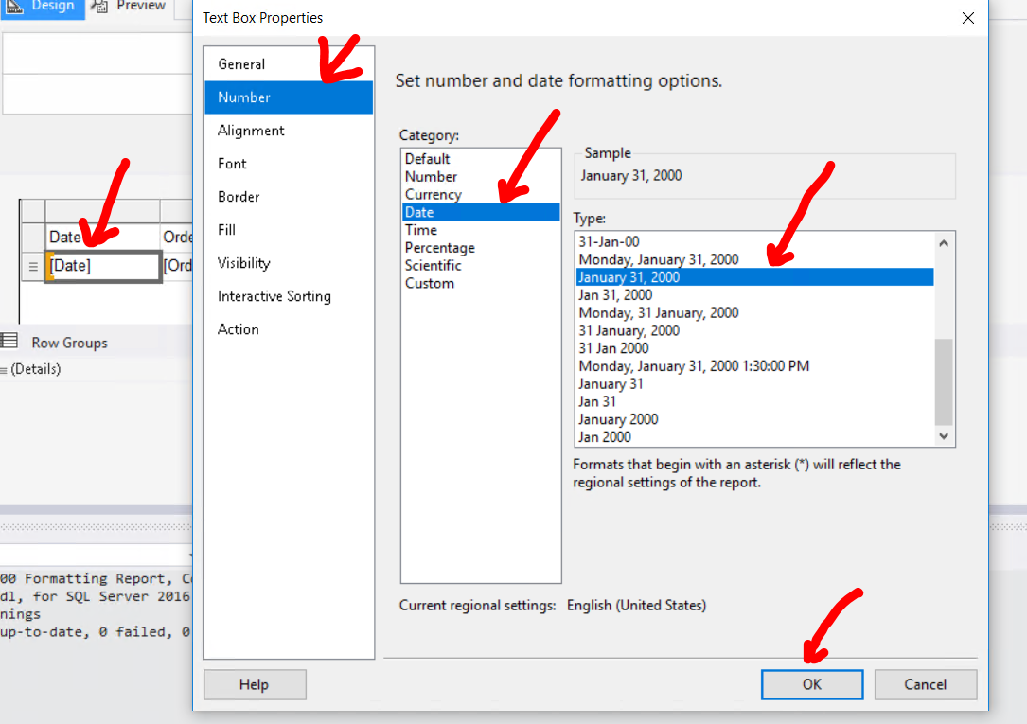Click OK.
6. 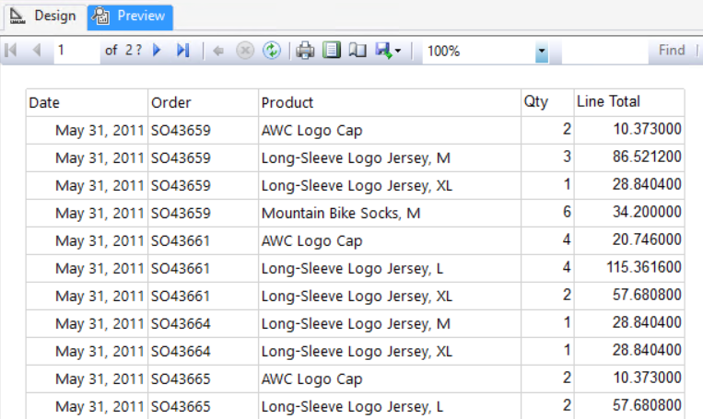Preview the report to see the change to the [Date] field

Format the LineTotal field

1. Go to Design
2. Right-click the cell with the [LineTotal] field expression and then click Text Box Properties.
3. Click Number, and in the Category field, click Currency.
4. Select Use 1000 separator (,).
5. Click OK.
6. Preview the report to see the change to the [LineTotal] field

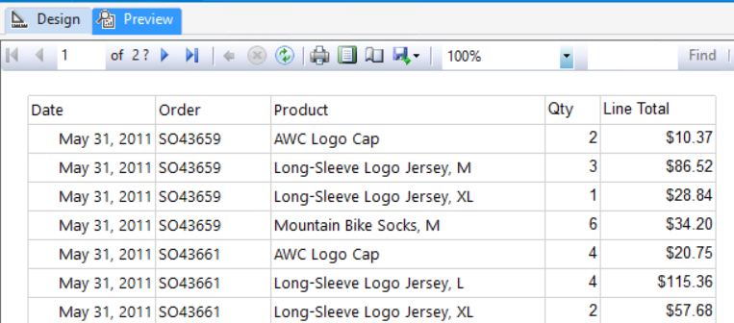

* Format Column width
* Format Row height
* Format Header font
* Format Header justification

